T-Shirt Shooter

**System Technical Specification**

**Specification No.: FRC5114-1**

**Revision 1**

**SEPT 24, 2015**

**Contacts:**

Todd Ferguson Andy Cocagne Sara Gadwa

Table of Contents

Revision Log 5

1 General Description 6

1.1 Scope 6

1.2 Applicable Documents 6

1.2.1 SAE and ISO Specifications 7

1.2.2 Materials Restrictions 7

1.3 Handling and Assembly Requirements 8

1.3.1 Shipping Containers 8

1.3.2 Handling Requirements 9

1.3.3 Assembly Requirements 9

1.3.3.1 Design for Manufacturability and Assembly (DFM/A) 9

1.3.3.2 Support for Product Assembly Document (PADs) 9

1.4 Development Samples 10

1.5 IPTV Targets 10

1.6 Cleanliness Requirements 10

1.7 Return Component Analysis 10

1.8 Labeling 10

1.9 Shipping 11

1.9.1 Shipping / Storage Requirements 11

1.9.2 Temperature 11

1.9.3 Altitude 11

1.9.4 Shipping Vibration / Shock 11

1.10 Operating Conditions 12

1.10.1 Operational Service Life 12

1.10.2 Temperature 12

1.10.3 Altitude 12

1.10.4 Environment 12

1.10.4.1 Fluid Exposure 12

1.10.4.2 Gaseous Exposure 14

1.10.4.3 Particulate Exposure 14

1.11 Electromagnetic Compatibility 14

2 Program specific requirements 15

2.1 Mass 15

2.2 Service Strategy – Solenoids 15

2.3 Sub-Component Functions 15

2.3.1 Pressure Control Solenoids - (Normally High) 15

2.3.2 Pressure Control Solenoids - (Normally Low) 15

2.3.3 Valve Body (Not included as part of this SOR) 16

2.4 Component Interfaces 16

2.4.1 Valve Body Assembly 16

2.4.2 Wire Harness Connector (Transmission Side) 16

2.5 Electrical Characteristics / Interfaces 16

2.5.1 Input Output Definition 16

2.5.1.1 Pressure Control Solenoids 16

The final dither strategy is a component technical specification deliverable and must be approved by GM Engineering. 17

2.5.1.2 Dither Parameters 17

The final dither strategy is a component technical specification deliverable and must be approved by GM Engineering. 17

2.5.1.3 Voltage / Current Ranges 17

2.5.2 Connector Requirements 17

2.6 Hydraulic Characteristics / Interfaces 18

2.7 Transmission Interfaces 18

3 Performance Requirements 20

3.1 General 20

3.2 High Voltage Leakage Test 21

3.3 Performance Tests for VFS 21

3.3.1 Coil Resistance 21

3.3.2 Inductance 21

3.3.3 Control Pressure Dead Band 22

3.3.4 Pressure Accuracy 22

3.3.4.1 Matching – Solenoid Pressure Performance 25

3.3.5 Hysteresis Test 26

3.3.6 Pressure Sweep Test 26

3.3.7 Step Pressure Response Time and Overshoot Test 26

3.3.8 Pressure Repeatability 27

3.3.9 Pressure Accuracy vs. Durability Drift 28

3.3.10 Pressure Accuracy Infant Drift 28

3.3.11 Pressure Accuracy vs. Time Drift 29

3.3.12 Maximum Response Time Test 29

3.3.13 Supply Pressure Sensitivity and Variation 30

3.3.14 Forward Flow Test 31

3.3.15 Reverse Flow Test 31

3.3.16 Cold Minimum Control Pressure Test 31

3.3.17 Cold Maximum Control Pressure Test 32

3.3.18 Leakage Test 32

4 Validation Plan 33

4.1 Performance Demonstration 33

4.2 Reliability demonstration 33

4.3 Durability demonstration 34

4.4 Failure Mode and Test Matrix 34

4.5 Materials usage list 34

4.6 Sampling Plans and success testing 35

4.7 Test fixture requirements 35

4.8 Test reports 35

4.9 Inspection 35

4.10 Test Environment Default Tolerances 36

4.11 Design Validation (DV) Test Flow Chart Example 37

4.12 DUT Operating Modes 38

4.13 Thermocouple Locations and Temperature Monitoring 38

4.14 Torque Values and Sequence Requirements 38

4.15 The Rapid Failure Mode Precipitation Test 38

4.16 Validation Tests 39

4.16.1 High Temperature Soak Test 39

4.16.2 Low Temperature Soak Test 39

4.16.3 Power Temperature Cycle Test 40

4.16.4 Procedure for Thermal Shock testing (optional) 41

4.16.5 Vibration Test at Temperature 41

4.16.6 Component Cycle Test 43

4.16.7 Metal Sliver Bridging Test 46

4.16.8 Contamination Abuse Tests with Carbonyl Iron 46

4.16.9 Mechanical Shock Test 47

4.16.10 High Pressure Test 48

4.16.11 Shelf Storage Test 48

4.16.12 Drop Test 48

4.16.13 Connector Validation per GMW 3191 48

4.16.14 Contamination Dwell Test 48

4.16.14.1 Test Contamination Levels 48

4.16.14.2 Test Conditions 49

4.16.14.3 Performance Measurements during Dwell Phase 49

4.16.14.4 Performance Measurements during Sweep Phase 49

4.16.14.5 Stretch Goal of Test 49

4.16.15 Dry Shifting Test RFMP #2 50

5 Appendix 51

5.1 Hydraulic Load Assembly 51

5.2 Important to Function / KPC / DR requirements 51

5.3 Establish & Implement Plan for Pull-ahead Production Tooling 51

Revision Log

| Date | Revision | **Section(s) Modified** | **Description** |
| --- | --- | --- | --- |
| 9/24/15 | 1 |  |  |
|  |  |  |  |
|  |  |  |  |
|  |  |  |  |
|  |  |  |  |
|  |  |  |  |
|  |  |  |  |
|  |  |  |  |
|  |  |  |  |
|  |  |  |  |
|  |  |  |  |
|  |  |  |  |
|  |  |  |  |
|  |  |  |  |
|  |  |  |  |
|  |  |  |  |
|  |  |  |  |
|  |  |  |  |
|  |  |  |  |
|  |  |  |  |
|  |  |  |  |

# General Description

## Scope

The T-shirt shooter is a device used to shoot 1 or more t-shirts under controlled conditions ...

This specification establishes the T-shirt shooter, hereafter referred to as TSS, requirements. These include performance, reliability, packaging, and validation requirements, which shall be met or exceeded.

Suppliers of the TSS shall demonstrate (through calculations, modeling, experimentation, testing, etc.) that the TSS will meet all of the specifications for all allowable variations due to dimensional tolerances, material and manufacturing / assembly process variations.

All Approved revisions to the CTS must be documented on the Controls Component print per the template below. This is to ensure adequate traceability with evolving design.

|  |  |  |  |  |  |  |  |  |  |  |  |  |
| --- | --- | --- | --- | --- | --- | --- | --- | --- | --- | --- | --- | --- |
|  |  | **Block for Controls PMT Component Prints** | | | | | | | |  | |  |
| **Part shall comply with latest version of component technical specification as shown in the table below** | | | | | | | | | | | | |
|  | | | | | | | | | | | | |
|  |  |  | | |  |  |  |  |  | |  |  |
| **Insert Actual CTS Name Here** | | | | | | | | | | | | |
| **Rev Level** | | **Date** | **EWO#** | **GPDS#** | | | | | | TKU# | | |
|  | |  |  |  | | | | | | n/a | | |
|  | |  |  |  | | | | | | n/a | | |
|  | |  |  |  | | | | | | n/a | | |
|  | |  |  |  | | | | | | n/a | | |

## Applicable Documents

### SAE and ISO Specifications

|  |  |
| --- | --- |
| TBD |  |
|  |  |
|  |  |

### Materials Restrictions

TBD



Subject: Proposed Revisions to EU Directive-Annex II

## Handling and Assembly Requirements

The following paragraphs define the handling and assembly requirements for the TSS.

### Shipping Containers

### Handling Requirements

### Assembly Requirements

The supplier is responsible for developing a TSS Assembly Plan. The plan shall include assembly requirements for integration of the TSS into the el Tigre Robot. The plan shall include, but is not limited to, the items identified in section 1.3.3.1 and section 1.3.3.2.

Note that the TSS shall be designed in such as way as to reduce or eliminate any specialized and/or costly handling requirements.

#### Design for Manufacturability and Assembly (DFM/A)

The supplier shall apply DFM/A design methods and tools prior to submitting design solutions to team management. DFM methods include focused workshops in which cross-functional design teams use a structured process to analyze and improve the design.

#### Support for Product Assembly Document (PADs)

TBD

## Development Samples

The supplier shall provide 1 sample to team management for evaluation. These samples must have production intent electrical characteristics and shall be provided a minimum of 1 week before the initial development samples are delivered.

## IPTV Targets

N/A

## Cleanliness Requirements

TBD

## Return Component Analysis

Returned (Development) Components must be tested for the reported failure.

## Labeling

Each part shall be identified on the exterior. Identification shall conform to the requirements of the team leader. The size and location of the identification shall be as shown in the Supplier’s Outline Drawing. Identification shall withstand the shooter worst case environment for the life of the robot.

## Shipping

TBD

### Shipping / Storage Requirements

The storage shelf life of the TSS shall be a minimum of TBD years. Solenoids shall be packaged and stored individually in specialized, long-term storage containers. The Supplier shall determine all solenoid storage requirements. All solenoid storage requirements must be approved by GMPT.

### Temperature

The solenoid shall withstand shipping / storage temperatures of -55º C to 60º C.

### Altitude

The altitude and temperature ranges during air shipment are 18 kilometers above to 150 meters below sea level and –55º C to 60º C.

### Shipping Vibration / Shock

While in storage or shipping, the HCM shall survive exposure to energy based on Table 1-1.

Table 1-1 Vibration Energy Shipping Requirements

|  |  |  |
| --- | --- | --- |
| BREAKPOINT | POWER SPECTRAL DENSITY (G2/Hz) | FREQUENCY (Hz) |
| 1 | 0.016 | 10 |
| 2 | 0.04 | 20 |
| 3 | 0.04 | 100 |
| 4 | 0.0008 | 800 |
| 5 | 0.0008 | 2000 |

## Operating Conditions

### Operational Service Life

TBD

### Temperature

All of the VFS internal devices shall be rated to permit the VFS to operate as specified in each of the following thermal environments listed in Table 1-2. The VFS shall not induce positive or negative pressure onto the vehicle wiring harness during operating temperature cycling. The testing shall include ten-minute transients 10º C above the maximum specified or 160º C maximum test temperature. These transients occur immediately following a temperature cycle at the maximum temperature with the engine, controller, and vehicle turned off.

Table 1-2 Operating Temperature Requirements

|  |  | CYCLE COUNT /TEMPERATURE RANGE (Degrees C) | | |
| --- | --- | --- | --- | --- |
| VFS LOCATION | THERMAL ENVIRONMENT | HOT SEASON | MODERATE SEASON | COLD SEASON |
| Internal  Transmission  Mount | Conduction | 1500 cycles/  25º C to 150º C | 3000 cycles/  -10º C to 150º C | 1500 cycles/  -40º C to 125º C |

### Altitude

Operation shall be 150 meters below to 4.750 kilometers above sea level. The VFS shall not induce positive or negative pressure onto the vehicle harness during pressure changes due to altitude exposure.

### Environment

The VFS shall be capable of operating in an internal transmission environment. The following paragraphs describe the operating environments of the VFS.

#### Fluid Exposure

VFS exposure shall include fully submerged in and exposed to splash from Dexron VI ~~or equivalent (reference Group 2 in the table listed below and ISO 16750-5 (Engine Compartment) for the list of the compatible fluids for the VFS) at temperatures specified in Table 1-3. Note that this oil may be contaminated as described in the Contamination Abuse Tests.~~  **REMOVE REFFERENCE TO TABLE 2. NOT EXPOSED TO ENGINE FLUIDS.**

Table 1-3 Test Fluid Requirements

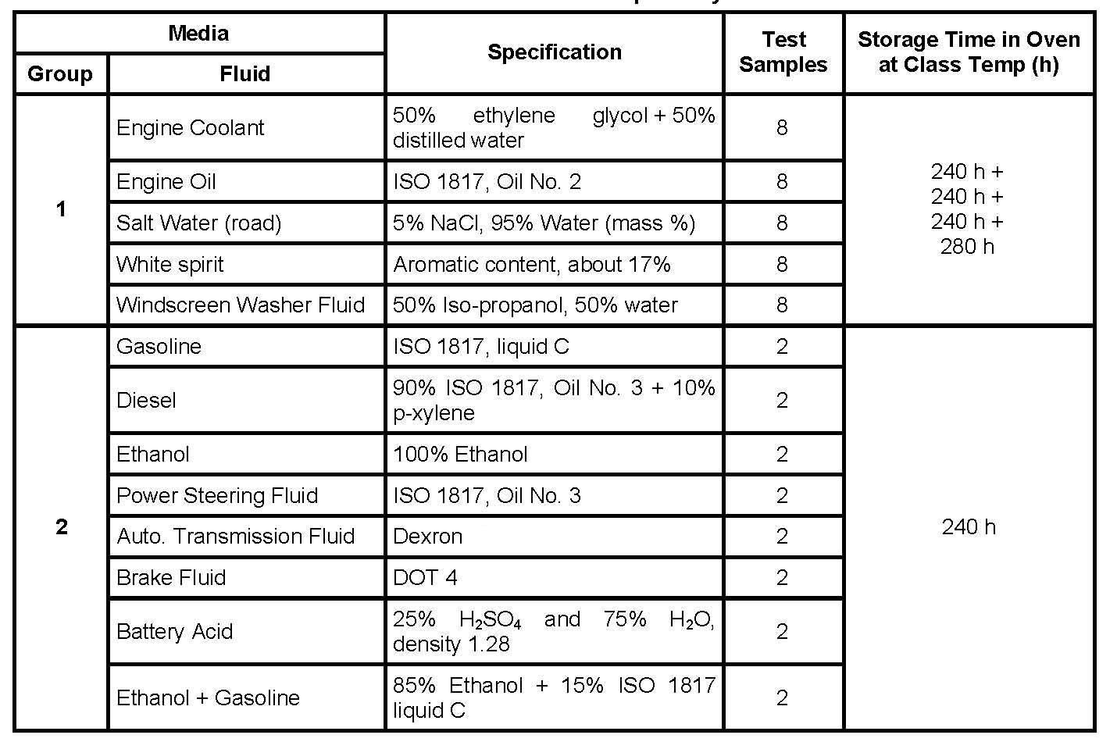

VI

Elastomeric Materials/Compounds Fluid Compatibility

The following tests (Items 1 & 2) are designated for Phase I and Phase II.

1. ASTM D471 at 150°C for 72 hours, 168 hours, 500 hours, 1008 and ~~1500~~ hours in Controls Factory Fill. Report changes of REMOVE 1500 HRS. TESTING HAS BEEN DONE UP TO 1008HRS

* Tensile strength
* Elongation
* Modulus at 50% and 100% elongations
* Hardness
* Volume swell
* 180° bending test by looping the aged specimens (25x50x2 mm) until the two ends meet & reporting any surface cracks under > 5X magnification
* For applications where rubber is bonded to metal or plastics, changes of bonding strength should also be reported (100% rubber failure should be expected)

1. Compression set (ASTM D395) and/or compression stress relaxation (ASTM D6147) at 150°C up to 1008 hours in Controls Factory Fill. Report CS and CSR as a function of fluid exposure time.

The following tests (Items 3, 4 & 5) are designated for Phase I only.

1. TMA (thermal expansion) for all materials new, at 72 hours, 500 hours and 1500 hours
2. Tan delta numbers for a -40 to 150 C temperature sweep at low frequency, low displacement for all materials new, at 72 hours, 500 hours and 1500 hours

TGA curve for all materials new and at 1500 hours

#### Gaseous Exposure

VFS exposure shall include completely surrounded at partial pressures. Exposure shall not cause corrosion or deterioration of materials which would degrade VFS performance when the VFS is properly connected to the vehicle harness. The VFS (and its connection system) shall not incur any corrosion-induced loss of functionality within the required useful life of the VFS in vehicle exposure. The VFS shall not induce positive or negative pressure onto the vehicle harness during gaseous exposure. The gases listed in ISO-16750-5 (Engine Compartment) shall be tolerated.

#### Particulate Exposure

VFS exposure shall include various particulates associated with the internal transmission environment. Exposure shall not cause corrosion or deterioration of materials that would degrade VFS performance or maintenance when the VFS is properly connected to the vehicle harness. The VFS (and its connection system) shall not incur any corrosion-induced loss of functionality within the required useful life of the VFS in vehicle exposure. The VFS shall not induce positive or negative pressure onto the vehicle harness. The particulates listed in ISO 16750-5 (Engine Compartment) shall be tolerated.

## Electromagnetic Compatibility

Supplier shall follow the Global EMC Component/Subsystem Validation Acceptance Process defined in GMW3103 for all EMC component design, development and validation. The component/subsystem shall pass both the component/subsystem level electromagnetic compatibility test(s) and the vehicle level electromagnetic compatibility test(s). In the event that a component/subsystem passes the component/subsystem level electromagnetic compatibility test(s) but does not pass the vehicle level electromagnetic compatibility test(s), the vehicle level test results shall be the determining factor for validation test pass/fail status.

Suppliers shall utilize the General Motors EMC Database (known by the acronym ‘CEMENT’), available via GM Supply Power. The suppliers shall

a) Register with the EMC database through GM Supply Power 100 days prior to the start of any EMC DV testing.

b) Register all components associated with the DV EMC testing into the database within 70 days prior to the start of a DV EMC testing

c) Submit (Upload) GMW3103 EMC Test Plans for approval by the GM EMC engineer within 60 days prior to the start of any DV EMC testing.

d) Submit a brief summary of any/all DV/PV data associated with any test under an approved EMC test plan within 5 working days of completion of that testing.

e) Submit all DV/PV data associated with an approved EMC test plan within 30 days of completion of the testing.

Note: The timing requirements specified here supplement but do not supersede or replace ADV program timing requirements specified in other GM documents and engineering standards such as GMW3172.

# Program specific requirements

## Mass

The VFS Mass shall not exceed more than 150g as shipped to GM.

## Service Strategy – Solenoids

**The solenoid body with the solenoids shall be serviced as entire module.**

## Sub-Component Functions

The following is a brief description of the functional and “reference” operational information relative to each sub-component VFS. The detailed sub-component requirements are defined in the appropriate sections of this specification.

### Pressure Control Solenoids - (Normally High)

Pressure Control Solenoids (normally high, 3-port, linear pressure control solenoids) are used to modulate pressure to spool type regulator valves (located in the transmission valve body), which in turn regulates pressure to the individual clutches within the transmission. The Pressure Control Solenoids are fed by Line oil with a nominal design pressure range of 275 kPa (235 kPa min/min) to 2100 kPa (2356 kPa max/max). These components shall be capable of providing a control pressure from between 0 and 1100 kPa at all temperatures and down stream flow demands. All Pressure Control Solenoids shall be capable of limiting the leakage (flow to exhaust) over the components lifetime.

### Pressure Control Solenoids - (Normally Low)

Pressure Control Solenoids (normally low, 3-port, linear pressure control solenoids) are used to modulate pressure to spool type regulator valves (located in the transmission valve body) to the individual Clutches within the transmission. The Clutch Pressure Control Solenoids are fed by Line pressure oil with a nominal design pressure range of 275 kPa (235 kPa min/min) to 2100 kPa (2356 kPa max/max). These components shall be capable of providing a control pressure from between 0 and 1100 kPa at all temperatures and down stream flow demands. Additionally, these solenoids shall be capable of limiting the leakage (flow to exhaust) over the components lifetime.

Table 2‑1 describes each Clutch Pressure Control Solenoid.

Table 2‑1 Pressure Control Solenoid Descriptions

**Neutral Gear Default**

|  |  |  |
| --- | --- | --- |
| **SOLENOID** | **DESCRIPTION** | **VFS SOLENOID TYPE** |
| Line | Line | NORMALLY HIGH |
| A | CB38 | NORMALLY LOW |
| B | C4 | NORMALLY LOW |
| TCC | TCC | NORMALLY LOW |

### Valve Body (Not included as part of this SOR)

The Valve body shall provide the necessary structure to house all of the VFS’s (as described above) and provide hydraulic routing / interfaces to connect these components to the transmission. The VFS shall provide integral filters on the supply and control ports designed to catch any particles too large to be ingested by the devices. GMPT’s intention is to prevent sub-components from particulate contamination. GMPT shall rely on the expertise of the Supplier to design and present for approval an appropriate filtration mechanism. Additionally, the filter shall be designed such that air entrapment (i.e. air pockets) and/or other anomalies shall not result in inconsistent sub-component behavior and/or inconsistent pressure control of the system. Refer to the Component Contamination Distribution and Concentration Table below for the typical contamination distribution observed in GMPT valve body environments (Equivalent to ISO 22/19 contamination level).

Table 2‑2 Component Contamination Distribution and Concentration Table

|  |  |
| --- | --- |
| **PARTICLE SIZE** | **CONCENTRATION** |
| > 2 microns | 73,000 particles / ml |
| > 3 microns | 47,000 particles / ml |
| > 5 microns | 21,000 particles / ml |
| > 10 microns | 3,000 particles / ml |
| > 20 microns | 300 particles / ml |
| > 30 microns | 20 particles / ml |
| > 40 microns | 3 particles / ml |
| > 80 microns | 1 particle / ml |

## Component Interfaces

The following is a brief description of the components that the interface with the VFS. Note that all of the components listed below are internal to the transmission and external to the VFS.

### Valve Body Assembly

The VFS shall be bolted or clipped to an aluminum valve body. The valve body shall be ported to provide the hydraulic inputs and outputs to the VFS. The VFS shall include any necessary sealing devices to prevent leakage at the valve body interface.

### Wire Harness Connector (Transmission Side)

The solenoid shall provide a Connection System. The entire connection system shall be approved by GMPT Engineering.

## Electrical Characteristics / Interfaces

The following paragraphs define the electrical characteristics and interfaces for the VFS.

### Input Output Definition

#### Pressure Control Solenoids

The Pressure Control solenoids shall be controlled by a GM current control output interface (CCO). The driver circuit shall provide a range of 0 to 1.2 Amps, 0.87 mA resolution, ± 3 mA accuracy over the specified temperature range (-40º C to 150º C), and repeatability of 1 mA. The current gain will be developed with actual hardware to ensure system can achieve pressure response requirements but minimize pressure overshoots. The supplier is expected to work with the controller supplier to define the interface that meets the GM system accuracy requirements.

The CCO shall provide a PWM Control driver connecting the low side of the load solenoid to PWRGND. The high side of the solenoid shall be supplied from a high side driver. The CCO interface shall provide a diode or equivalent device to circulate the solenoid current from low side to high side during the intervals when the PWM Control driver is off. Diode voltage will be 1.6 V.

The VFS supplier shall provide GM a data file containing the dither amplitudes used for each solenoid. The data shall consist of dither amplitudes (mA) as a function of temperature and final commanded current. In addition, the VFS supplier shall also provide the dither frequency (or multiple dither frequencies as a function of temperature). The supplier and GM shall work together to establish the format of the Dither data files. The VFS supplier shall submit the final data file to GM for review.

#### The final dither strategy is a component technical specification deliverable and must be approved by GM Engineering.

#### Dither Parameters

The solenoid supplier shall propose a baseline dither strategy (Frequency and Amplitude) that works best in their component level testing. The final dither strategy will be co-developed with GM using transmission dynamometer and vehicles. The expected dither frequency range is 20 Hz to 400Hz and the dither amplitude range should be 0 mA to 400 mA (peak to peak).

The solenoid dither frequency and amplitude will be selected by the supplier, based on solenoid performance.

Dither amplitude will be determined at ten (10) temperatures ranging between -40º C and 150 º C. The temperature points can be non-linearly distributed across the range and are selectable by the supplier to ensure optimum solenoid performance.

For each selected temperature, the supplier will determine dither amplitude at 6 final current points ranging between 0 A and 1.2 A. The current points can be non-linearly distributed across the range and are selectable by the supplier to ensure optimum solenoid performance.

#### The final dither strategy is a component technical specification deliverable and must be approved by GM Engineering.

#### Voltage / Current Ranges

Maximum current draw by the VFS during all operating conditions except for double jump start shall not exceed the requirements defined below (as worst case):

VFS 1.2 A RMS.

### Connector Requirements

All connection systems shall meet USCAR 25, USCAR 21 and GMW 14234 requirements. The supplier shall choose a connector provided it meets the USCAR footprint and GMW3191 (Temperature Class 3* Transmission, Vibration Class 5) requirements. The connector supplier will be responsible for validation of connector. Final connector selection shall be approved by GMPT Engineering. The connection system shall contain connector position assurance features (CPA) to ensure that the connector is fully seated into the harness connector. The mating connector shall be of different, high-contrast colors to enable visual seating of the mating connectors. Final connector colors to be defined by GMPT with supplier.

Both halves of the connection system shall be easily protected from damage during shipping to transmission assembly plant. The assembly of the connection system shall not damage the connector, the mating connector, or the assembler. Particular attention shall be given to ergonomic specifications such as maximum installation forces and handling requirements.

The connection system shall withstand 20 mating cycles during calibration and development. The connection system shall withstand a minimum of 10 mating cycles in a production vehicle.

The supplier shall provide sufficient component connectors (approx. 150) at each design level free of charge to the GM wire harness supplier for design and process validation of the connection system to GMW 3191.

The following tables characterize and define the VFS interface connections.

Table 2‑3 Connectors

|  |  |  |  |
| --- | --- | --- | --- |
| CONNECTOR | CONNECTOR P/N | TOTAL PINS | PINS USED |
| VFS | Defined by Supplier – approved by GMPT | 2 | 2 |

## 

## Hydraulic Characteristics / Interfaces

Table 2‑4 and Table 2‑5 summarize the hydraulic input and output characteristics for VFS interfaces, respectively.

Table 2‑4 VFS Input Interfaces

|  |  |  |  |
| --- | --- | --- | --- |
| TYPE | **TYPE OF INPUT** | **OPERATING PRESSURE RANGE** | **PROOF PRESSURE** |
| Line Pressure | Solenoid Supply | 275 – 2100 kPa | 3447 kPa |
| A | Solenoid Supply | 275 – 2100 kPa | 3447 kPa |
| B | Solenoid Supply | 275 – 2100 kPa | 3447 kPa |
| TCC | Solenoid Supply | 275 – 2100 kPa | 3447 kPa |

Table 2‑5 VFS Output Interfaces

**Neutral Gear Default**

|  |  |  |
| --- | --- | --- |
| **TYPE** | **TYPE OF OUTPUT** | **NOMINAL OUTPUT PRESSURE** |
| Line | Line | 0 – 1100 |
| A | CB38 | 0 – 1100 kPa |
| B | C4 | 0 – 1100 kPa |
| TCC | TCC | 0 – 1100 kPa |

## Transmission Interfaces

The VFS Template Drawing / Model will be used in conjunction with the specification to define envelope and interface requirements. Reference VALVE ASM-SHFT SOL (GENERIC) (VFS-PRESSURE CONTROL) for application space claim and dimensional information (issued to Supplier upon request). For packaging reference, see below.

The VFS shall have an anti-rotation feature that interfaces to the solenoid body casting. The (N/H) and (N/L) VFS shall distinct features within nozzle designs to allow for error-proofing during installation into solenoid body assembly.

**COMMON ENVIRONMENT packaging**

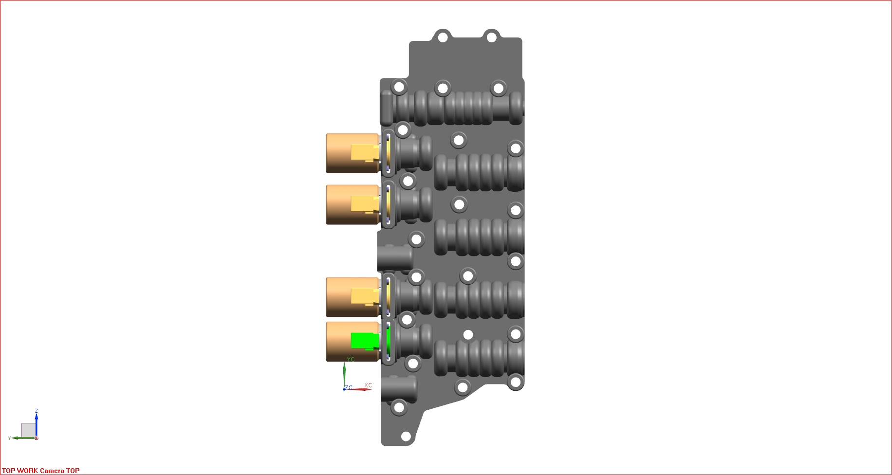

VFS-PRESSURE CONTROL (N/L)

P/N 24268037

VFS-PRESSURE CONTROL (N/H)

P/N 24268038

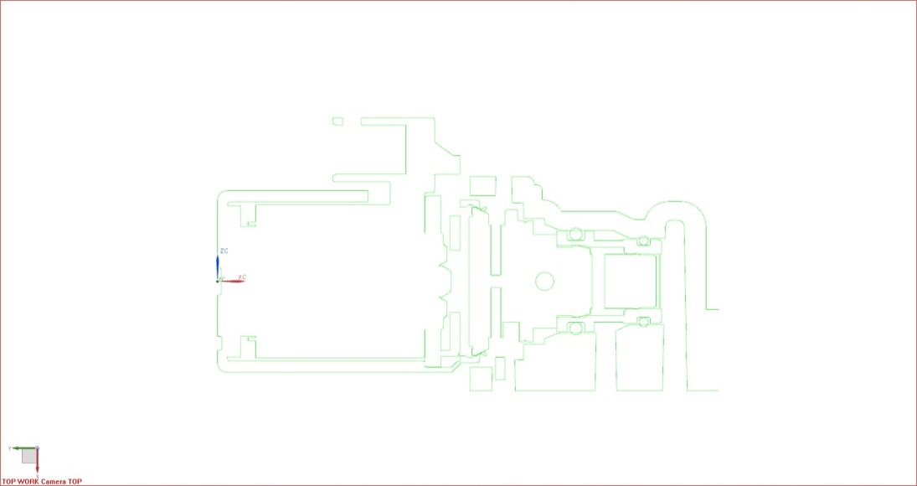

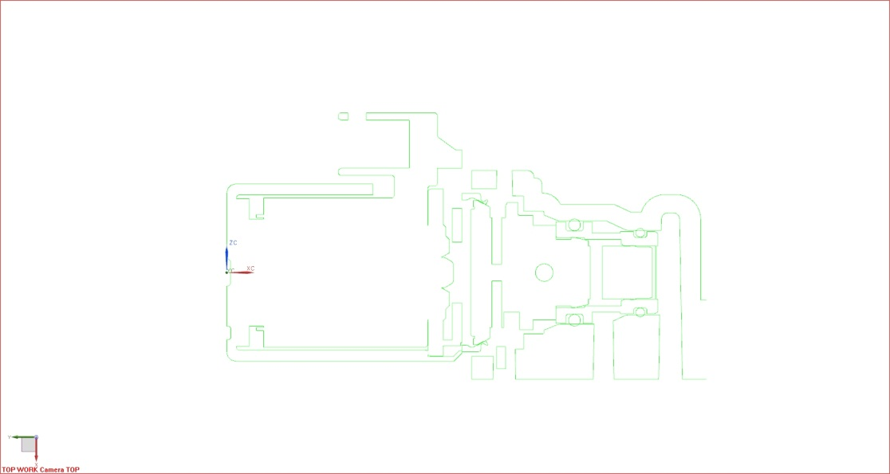

VFS-PRESSURE CONTROL (N/H) VFS-PRESSURE CONTROL (N/L)

P/N 24268038 P/N 24268037

# Performance Requirements

The following paragraphs define the performance requirements for the VFS. Unless otherwise specified, these requirements apply to the complete assembly.

## General

In order to verify the performance requirements of the VFS, the actual characteristics shall be measured and recorded. This information will be reviewed with GMPT in regularly schedule design review sessions. All measurement procedures shall be reviewed and approved by GM. This includes and is not limited to the measurement of pressure, current, temperature, and flow magnitudes in both the time and frequency domains. Special attention will be paid to measurements where high frequency data collection is necessary in order to verify that the VFS has passed or failed a specific test. A statistical +/- 3 sigma capability that the VFS design meets the specifications shall be calculated. The measured data shall be archived by the supplier and made available to GMPT in both hardcopy and electronic formats at GMPT’s request. All specifications outlined in this document are to be passed with gage repeatability and reproducibility inclusive to the actual measurements (Limits must be guard-banded). All test systems where measured data is acquired must meet the gage requirements.

In addition, all units delivered to GMPT Engineering shall have all critical product characteristics measured and archived by VFS serial number. Statistical data shall be collected on these parameters during production to audit the product performance. These measurements shall be made at 20° ± 2° C and 70º + 2º C (14 VDC operating voltage). A list of all critical product characteristics will be determined jointly by the GMPT Engineering and the Supplier. Note that the quantity of units tested may be reduced by GMPT once desired product confidence levels are achieved.

All Hydraulics actuators and sensors shall be tested at 20° ± 2° C and 70º+ 2º C fluid temperature, unless otherwise specified.

For any test conditions below Zero °C, the fluid pressure shall be supplied by one of the following:

* A pressure vessel filled with fluid at the specified temperature which is pressurized with a gas such as air or nitrogen
* A fluid reservoir, motorized pump, and heat exchanger system configured to insure zero net heat transfer to the fluid.

The supply tank shall be filled with test fluid and cooled until the supply tank, test fixture, and solenoid have stabilized at the desired test temperature for a minimum of one hour prior to the test. To ensure that the required test temperature is achieved, the solenoid must be maintained in the de-energized state (0 power) during this soak time. Bleed the supply port and chamber port before performing the test.

The VFS shall be mounted on a test fixture with the same mounting configuration, sealing configuration, cooling flow / strategy, and orientation(s) as on the transmission(s). All filters / screens used in conjunction with the VFS shall be in place during all tests unless otherwise specified. Pressure / Flow measurements shall be taken on the appropriate side of the filters / screens to represent operating conditions within the transmission. All tests shall be performed with a hydraulic load defined by GMPT Engineering, see Appendix 5.1 for more information.

The pressure control solenoid control pressure shall not vary by more than ± 10 kPa when the VFS is exposed to ± 1.0 g acceleration levels. Specifically, acceleration directions that can impart a force on the moving parts of the pressure control solenoids in such a way as to affect the output pressure, i.e. in the axial and perpendicular directions to the armature. The supplier shall verify this requirement by testing the components in the vehicle orientation to establish the baseline curve. The components must then be rotated 90° and 180° around the axis of the armature stroke.

Supply pressure shall be applied to the supply port(s) of the VFS, the control ports shall be connected to the specified hydraulic circuits, which represent transmission function, and the exhaust ports shall be allowed to vent to atmospheric pressure unless otherwise specified.

The test fluid shall be DEX VIoil unless otherwise specified.

The controller P/N to be used for all testing (Including validation) will be mandated by GM. The VFS supplier must be purchase these controllers for all testing including validation. The VFS supplier must integrate this controller in their test equipment and all performance requirements in this specification include controller inaccuracies. TCM supplier will provide controller test code using a CAN interface.

The supplier shall verify that the solenoids are used in a manner deemed acceptable (ex. current range, controller ground strategy, dynamic current characteristics, chopper and dither frequency ranges, and mechanical attachments).

## High Voltage Leakage Test

Apply 1000 ± 25 VDC minimum between either of the terminals and the solenoid case. The measured leakage current during this test shall not exceed 1.2 mA when measured at 20 ± 5 °C.

Repeat this test at 150º C. Measured leakage current during this test shall not exceed 1.2 mA.

## Performance Tests for VFS

The following paragraphs define the performance tests for pressure control type solenoids.

The following tests must a complete VFS with the same supply and control port configuration as in the transmission. The GM DRE must approve the VFS suppliers test setup before testing can be completed.

### Coil Resistance

The resistance between the solenoid terminals shall be 5.0 ± 0.2 Ω at 20 °C.

### Inductance

Calculate the solenoid inductance from the time for current to rise from 0 to 1.0 Amp when a 12 VDC step input is applied. Solenoid inductance must be 15 ± 5 mH.

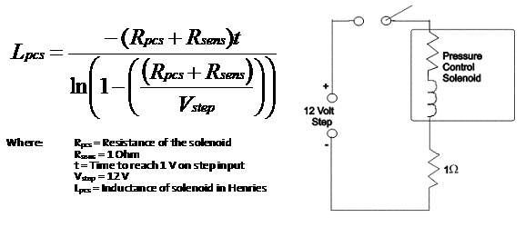

### Control Pressure Dead Band

The VFS supplier shall design the pressure control solenoids to have 100 mA minimum “dead band” at each end of the current range. Dead band is defined as either ensuring 0 kPa control pressure or control pressures greater than 1100 kPa (supplier must use 100 mA to 1100 mA to obtain 0 kPa to 1100 kPa control pressure).

The current dead band is used for temperature and supply pressure compensation.

### Control Pressure to Force Gain Requirement

### The pressure gain for any variable force solenoid shall be less than 100 kPa/N.

For this specific application the control pressure requirement is 1100 kPa which requires a minimum of 11.1 N of magnetic force to achieve the 1100 kPa control pressure requirement.

### Based on past experience with VFS components, the contamination robustness of the device is dependent on the total available force over the control pressure range. Benchmarking of our current products and competitors has shown that the device will be significantly less sensitive to the contamination in a typical transmission environment when the pressure gain is less than this requirement.

### Pressure Accuracy

The supplier shall provide pressure control solenoids that meet the following criteria.

Connect a hydraulic load; O’Keefe orifice # D-7-SS, to the control port of the pressure control solenoid as described in Appendix 5.

The control pressure gain (Δ Pressure / Δ Current) must not exceed 1.8 kPa/mA at all current steps.

The nominal control pressure must be greater than 1100 kPa before the current range limit is reached at all temperatures with 2100 kPa supply pressure.

The supplier shall provide the nominal control pressure vs. commanded current at each temperatures in this specification and in the VFS compensation tables. This test will be performed at 2100 Kpa. A minimum of 30 VFS’s shall be tested at each design level to calculate the nominal offset from the EOL test parameters~~.~~. The data will be used to develop a temperature and supply pressure compensation strategy and the production nominal control pressure vs. current curves shall be added to this specification once this information is provided by the supplier.

The VFS supplier shall provide GM a data file containing the results of the supply pressure and temperature sensitivity tests. The data shall contain the required current offsets (mA) in order to achieve the desired pressure at temperatures and supply pressures identified in this specification. The supplier and GM shall work together to establish the format of the temperature and supply pressure sensitivity data file. The supplier shall submit the final data file to GM for review and approval.

Set the test stand supply pressure to 2100 ±10 kPa. Command control pressure steps from 0 kPa to 1100 kPa and back to 0 kPa in 55 kPa steps. The time between all commanded steps shall be long enough for pressure to stabilize (determined by supplier). The temperatures to be tested are listed in Table 3-2. Repeat each test at a given temperature and supply pressure 10 times. Measure and record the test stand supply pressure, commanded current, commanded pressure, and control pressure for each step value.

Actual control pressures for the accuracy test will be calculated by averaging the results of the 10 tests for each commanded current and temperature. Increasing and decreasing current steps shall be averaged independently. Control pressure accuracy will be evaluated by comparing the commanded pressure -vs-actual (averaged) control pressure recorded from 0 kPa to 1100 kPa. The evaluation range will also be limited to the operating range where the nominal control pressure is < 90% of the supply pressure. The difference between the commanded control pressure and actual (averaged) control pressures shall be less than or equal to (≤) the magnitudes shown in Table 3-1 for any given temperature.

The solenoid must pass the same criteria when the test is repeated at 275 ± 5 kPa and 1200 ± 10 kPa test stand supply pressure.

In addition, throughout the life of the product, with a 2100 ± 10 kPa supply pressure, the maximum control pressure must always be greater than 1054 kPa, and the minimum control pressure must always be less than 25 kPa.

When using an appropriate low pass filter, the pressure shall have no greater than **TBD** ~~25~~ kPa peak to peak oscillation at 2100 kPa and 1200 kPa supply and no greater than **TBD** ~~12~~ kPa peak to peak oscillation at 275 kPa supply.

Table 3-1 Accuracy Table

|  |  |
| --- | --- |
| **Temperature (º C)** | **Error from Commanded Control Pressure (± kPa)**  **(This shall be a ±3 sigma normal distribution)** |
| -30 | **43** |
| -20 | **26** |
| 0 | **26** |
| 20 | **22** |
| 50 | **22** |
| 70 | **10** |
| 90 | **22** |
| 110 | **22** |
| 125 | **22** |
| 150 | **22** |

In addition to meeting the overall accuracy specifications listed above, the pressure deviation between adjacent test temperatures for each VFS at the 0 kPa to 1100 kPa in 55 kPa step commanded pressures shall be no more than the values listed in Table 3-2 below. This data will consist of the 10 test averaged pressure value during the pressure profile step test. The additional Infant Drift allowance will NOT be applied to this specification. The additional Durability Drift allowance for this specification will be ± 5 kPa. Temperature compensation shall be active for this requirement.

Table 3-2 Pressure Change w/ Temperature Table

|  |  |
| --- | --- |
| **Temperatures (º C )** | **Actual VFS Pressure (kPa)** |
| -30 to -20 | ±18 |
| -20 to 0 | ±12 |
| 0 to 20 | ±9 |
| 20 to 50 | ±9 |
| 50 to 70 | ±6 |
| 70 to 90 | ±6 |
| 90 to 110 | ±6 |
| 110 to 125 | ±6 |
| 125 to 150 | ±9 |

The performance for each specific solenoid shall meet the following temperature sensitivity requirement. The actual measured control pressure difference at 55 kPa to 1100 kPa in 55 kPa step commanded pressures from the actual measured control pressure at 70° C shall be within the limits specified in Table 3-3 below. This data will consist of the 10 test averaged pressure value during the pressure profile step test. The additional Infant Drift allowance will NOT be applied to this specification. The additional Durability Drift allowance for this specification will be ±5 kPa. Temperature compensation shall be active for this requirement.

Table 3-3 Maximum Allowable Temperature Sensitivity

|  |  |
| --- | --- |
| Temperature (° C) | Δ Control Pressure (kPa) |
| 70 to -30 | ±17 |
| 70 to -20 | ±17 |
| 70 to 0 | ±12 |

At each temperature between 0C and 135C, for each step to commanded pressures of 55 kPa to 1100 kPa in 55 kPa step commanded pressures, the resulting measured pressure shall change relative to the previous step pressure value within the limits as shown in Table 3-4 below. This data will consist of the 10 test averaged pressure value during the pressure profile step test. The additional Infant Drift allowance will NOT be applied to this specification. The additional Durability Drift allowance for this specification will be ±5 kPa.

Table 3-4 Pressure Step Table

|  |  |
| --- | --- |
| **Pressure Step Command (kPa)** | **Measured Step Pressure (kPa)** |
| 0-35 | 35 +7/-22 |
| 35 – 55 | 20 +/-7 |
| 55 – 110 | 55 ± 7 |
| 110 – 165 | 55 ± 7 |
| 165 – 220 | 55 ± 7 |
| 220 - 275 | 55 ± 7 |
| 275 – 330 | 55 ± 7 |
| 330 – 385 | 55 ± 7 |
| 385 – 440 | 55 ± 7 |
| 440 – 495 | 55 ± 7 |
| 495 – 550 | 55 ± 7 |
| 550 – 605 | 55 ± 7 |
| 605 – 660 | 55 ± 7 |
| 660 – 715 | 55 ± 7 |
| 715 – 770 | 55 ± 7 |
| 770 – 825 | 55 ± 7 |
| 825 – 880 | 55 ± 7 |
| 880 – 935 | 55 ± 7 |
| 935 – 990 | 55 ± 7 |
| 990 – 1045 | 55 ± 7 |
| ~~1045 – 1100~~ | ~~55 ± 7~~ |

#### The VFS supplier shall use a GM proprietary pressure to current algorithm for the P-P tests specified in this SOR. The attached file contains the functional architecture for the pressure to current algorithm. The VFS supplier shall be responsible for implementing this algorithm in the test environment.

The accuracy specification applies to a VFS that has accumulated less than 100 hours of operation

95% of the data at any given temperature or temperature step must meet this criteria, any points outside of these limits must be approved by GMPT.

### Matching – Solenoid Pressure Performance

The supplier, as part of their final / acceptance tests on each production and developmental unit, shall “characterize” the electro-hydraulic component characteristics. The characterizing of the components shall take place at 70 ± 2ºC, ~~20± 2ºC~~, and 2100 ± 10 kPa supply pressure.

For each solenoid, connect a solenoid into pressure test bench with a hydraulic load O’Keefe orifice (ref. Appendix 5) installed into the control port of the pressure control solenoid. Perform electrical function checks. Set the supply pressure to 2100 kPa +/- 10 kPa and the temperature to 70 ± 2º C. Sweep the current from 0 mA to 1.2 A and back to 0 mA in 50 mA steps. The time between all commanded steps shall be long enough for pressure to stabilize (determined by supplier). Record the supply pressure, control pressure, oil temperature, and commanded current during the test. Repeat procedure for second match point at 20 ± 2 °C and 2100 ± 10 kPa.

The VFS supplier shall use fixed current points for increasing and decreasing measurements and provide the measured pressure at each of the fixed current point. Each data point will be a commanded current value and the corresponding control pressure measured at the commanded current. These values are referred to as the “solenoid characterization data”.

The commanded current points for the solenoid are to be jointly developed by the supplier and GM and are the points that can best be used to interpolate the actual solenoid performance over the swept current range. The increasing current points must be the same as the decreasing current points that are selected. Once the currents values are optimized, they will remain fixed (solenoid to solenoid). All solenoids will share these common selected current points (NH and NL Solenoids). The solenoid characterization method shall be submitted to GMPT for review and approval.

The supplier shall upload this characterization data into a GM database per the attached specification.



The solenoid characterization data shall consist of two sets of pressure curve data. Each set shall consist of up to 21 increasing pressure points and 21 decreasing pressure points (up to 42 pressure data values per set). Each set of data curves corresponds to one of the match points. This data will be indexed to correspond with the fixed current points. In addition to the two sets of pressure data, the 2D barcode shall also contain solenoid position information, solenoid type, control type, and solenoid data checksum information. The solenoid characterization data shall be stored on the 2D bar code using a GM proprietary compression algorithm. The final format, bar code size, and bar code performance requirements shall be reviewed and approved by GMPT.

The supplier is responsible for providing all necessary test and measurement equipment as well as all supplier-used components required for developing and validating these procedures. The detailed procedures shall clearly identify the pass / fail criteria and required action in the event of a test incident.

GM shall receive all production and developmental solenoids as characterized components unless a specific prior agreement has been made between GM and the supplier stating otherwise.

During the development phase and production phases of the program, the supplier shall provide a data file containing the solenoid characterization data associated with each solenoid per the attached specifications.

 

### Hysteresis Test

Pressure control solenoid hysteresis shall be calculated by comparing the actual solenoid output pressure recorded during the increasing pressure step command to the actual output pressure recorded during the decreasing pressure step command. This shall be calcu4.7lated for each increasing step/decreasing step pair without averaging. The pressure control solenoid hysteresis shall be evaluated at each 55 kPa step from 0 kPa to 1100 kPa.

The actual pressure control solenoid output pressure measured from each individual decreasing pressure step shall not vary more than 12 kPa maximum from the actual output pressure measured from the corresponding individual increasing pressure step when hysteresis compensation software is active.

### Pressure Sweep Test

Connect a hydraulic load; O’Keefe orifice # D-7-SS, to the control port of the pressure control solenoid. Set the supply pressure to 2100 ± 10 kPa and fluid temperature to 70º ± 2º C. With a step size of 7 kPa, continuously sweep the solenoid at a 50 kPa/sec rate from 0 kPa to 1105Kpa and back to 0 kPa. Record the supply pressure, control pressure, and current during the test.

Repeat this test at 20º ±2º C and 150º ±2º C. The same pass/fail criteria as the 70º ±2º C shall apply. All commanded pressure control solenoid pressure changes during the sweep test shall be continuous.

Plot this pressure data as a continuous curve. The evaluation range will consist of the data recorded between 55 kPa and 1000 kPa control pressures. This data will be evaluated by comparing each 7 kPa change in commanded pressure to the actual output pressure. Each 7 kPa change in commanded pressure shall result in an actual control pressure change of ~~5 ± 2.5~~ kPa. 7+/-3.5 kPa .

When using an appropriate low pass filter, the pressure shall have no greater than **TBD (by BW)** kPa peak to peak oscillation at 2100 kPa and 1200 kPa supply and no greater than **TBD (by BW)** kPa peak to peak oscillation.

### Step Pressure Response Time and Overshoot Test

The desired transient pressure response of the pressure control solenoid to a step input shall resemble that of a critically damped to under-damped, ζ < 1, second order system.

Connect a hydraulic load; O’Keefe orifice # D-7-SS, to the control port of the pressure control solenoid. Set the supply pressure to 2100 ± 10 kPa. Step the pressure from 0 kPa to 1100 kPa and back to 0 kPa in 55 kPa steps for each condition identified in Table 3-5 below. Allow 450 ms maximum pressure stabilization at each step. Measure and record the supply pressure, commanded pressure, control pressure, and current for each step value.

In addition, for pressure steps 55kPa and below the pressure profile of the actual control pressure shall not have an undershoot with a magnitude that is greater than (>) 5% of the actual pressure change or an overshoot with a magnitude that is greater than (>) 10% of the actual pressure change (Pressure difference from initial control pressure to final control pressure), unless the delta between the 90% step time and the peak of the overshoot is less than 80 ms or the delta between the 90% step time and the peak of the undershoot is less than 160 ms. See Figure 3.1 for graphical explanation of 90% step time and overshoot time.

For pressure steps above 55kPa the pressure profile of the actual control pressure shall not have an undershoot with a magnitude that is greater than (>) 5% of the actual pressure change or an overshoot with a magnitude that is greater than (>) 10% of the actual pressure change (Pressure difference from initial control pressure to final control pressure), unless the delta between the 90% step time and the peak of the overshoot is less than 30 ms or the delta between the 90% step time and the peak of the undershoot is less than 60 ms.See Figure 3.1 for graphical explanation of 90% step time and overshoot time.

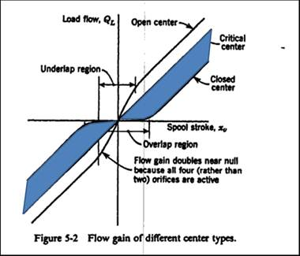

The supplier shall design the solenoid with a critical to “slight” overlap valve configuration. The final flow gain curves must be provided to GM for review and approval at the solenoid technical review.

Table 3-5 Step Test Specifications

|  |  |  |
| --- | --- | --- |
| **TEST NUMBER** | **TEMPERATURE (º C)** | **NUMBER OF TEST RUNS** |
| 1 | 20 | 2 |
| 2 | 40 | 2 |
| 3 | 70 | 2 |
| 4 | 150 | 2 |

**Figure 3.1 – Step Response & Overshoot Diagram**

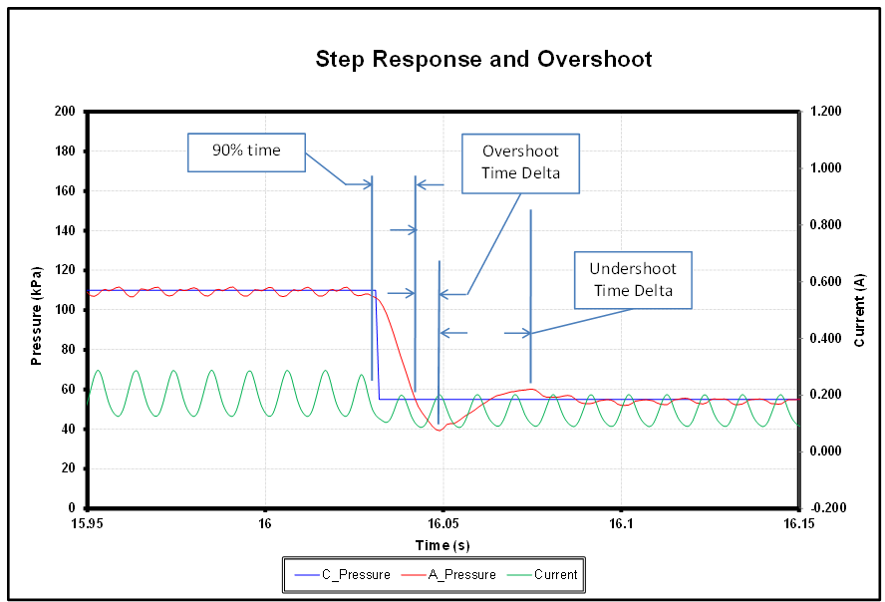

**Table 3-6. Allowable 90% Step Time per Increasing Pressure Step (70°C, 896 kPa Supply)**



Table 3-7. Allowable 90% Step Time Per Decreasing Pressure Step (70°C, 896 kPa Supply)



### Pressure Repeatability

Set the test stand supply pressure to 2100 ± 10 kPa. Command pressure steps in the order given: Step the pressure from 0 kPa to 1100 kPa and back to 0 kPa in 55 kPa steps. The time between all commanded steps shall be long enough for pressure to stabilize (determined by supplier, but not to exceed 500 ms). The temperatures to be tested are listed in Table 3-6. Measure and record the test stand supply pressure, commanded pressure, actual pressure, and current for each step value. Repeat each test 10 times.

Set the test stand supply pressure to 275 ± 5 kPa. Command pressure steps in the order given: Step the pressure from 0 kPa to 275 kPa and back to 0 kPa in 55 kPa steps. The time between all commanded steps shall be long enough for pressure to stabilize (determined by supplier, but not to exceed 1 second). The temperatures to be tested are listed in Table 3-6. Measure and record the test stand supply pressure, commanded clutch pressure and actual clutch pressure for each step value. Repeat each test 10 times.

Set the test stand supply pressure to 1200 ± 10 kPa. Command pressure steps in the order given: Step the pressure from 0 kPa to 1100 kPa and back to 0 kPa in 55 kPa steps. The time between all commanded steps shall be long enough for pressure to stabilize (determined by supplier, but not to exceed 1 second). The temperatures to be tested are listed in Table 3-7. Measure and record the test stand supply pressure, commanded clutch pressure and actual clutch pressure for each step value. Repeat each test 10 times.

The measured control pressure for any given supply pressure, temperature and commanded pressure shall not vary by more than a pressure range as defined in Table 3-6 (Range of the 10 measured values at each commanded pressure).

Table 3-8. Repeatability Test Criteria

|  |  |  |
| --- | --- | --- |
| **TEMPERATURE (degrees C)** | **Allowable Pressure Range**  **(For 1200 and 2100 kPa Supply)** | **Allowable Pressure Range**  **(For 275 kPa Supply)** |
| -30 | 23 kPa | 23 kPa |
| -20 | 17 kPa | 17 kPa |
| 0 | 12 kPa | 12 |
| 20 | 12 kPa | 12 |
| 50 | 12 kPa | 12 |
| 70 | 12 kPa | 12 |
| 90 | 12 kPa | 12 |
| 110 | 12 kPa | 12 |
| 125 | 12 kPa | 12 |
| 150 | 12 kPa | 12 |

### Pressure Accuracy vs. Durability Drift

For any temperature and supply pressure, the actual control pressure from the solenoid shall not drift more than 29 kPa from the accuracy specification outlined in section 3.3.4 throughout the life of the part.

After the pressure control solenoid has accumulated a number of cycles, perform the accuracy test. The pressure control solenoids shall pass the accuracy specifications outlined in 3.3.4 with the additional Durability Drift tolerances (except where noted).

The solenoid must pass the accuracy criteria when the test is conducted at 275 ± 10 kPa, 1200 ± 10 kPa, and 2100 ± 10 kPa test stand supply pressures.

In addition, throughout the life of the product, with a 2100 ± 10 kPa supply pressure, the maximum control pressure must always be greater than 1054 kPa, and the minimum control pressure must always be less than 25 kPa.

This additional tolerance may be applied to any post durability accuracy limit outlined in section 4.

### Pressure Accuracy Infant Drift

Set the supply pressure to 2100 ± 10 kPa and the temperature to 70 ± 2º C. Command pressure steps in the order given: Step the pressure from 0 kPa to 1100 kPa and back to 0 kPa in 55 kPa steps. Measure and record the commanded pressure, supply pressure, and actual control pressure. Increase the temperature to 150 ± 2º C. Immerse the solenoid at 150 ± 2º C fluid and energize each solenoid with “maximum” current for 4 hours. Change the fluid temperature back to 70 ±2ºC and set the supply pressure to 2100 ± 10 kPa. Command pressure steps in the order given: Step the pressure from 0 kPa to 1100 kPa and back to 0 kPa in 55 kPa steps.

The difference between the control pressure readings before and after the thermal soak must not exceed ~~17~~ 20 kPa.

### Pressure Accuracy vs. Time Drift

Set the supply pressure to 2100 ± 10 kPa and the temperature to 70º ±2º C. Command 330 kPa. Measure and record the control pressure.

The actual control pressure measured 5 seconds after the step command must be less than or equal to (</=) 3.5 kPa the control pressure recorded at 300 ms after the pressure command.

These measurements will be the mean value measured for a duration of 300 ms and appropriate low pass filter for each of the 300 ms and 5 sec intervals.

### Maximum Response Time Test

With a hydraulic load, O’Keefe orifice # D-7-SS, connected to the control port of the solenoid, pressurize the supply port of the solenoids to 1250 ± 10 kPa. Subject the solenoids to a step input of minimum to maximum command pressure. Record the supply pressure, control pressure and current.

The control port volume for this test must be 6.2 ± 1 ml, shall include the hydraulic load specified in Appendix 5 and an accumulator per the following specification.



Determine the “On” response time of the solenoids from control pressure and command pressure. “On” response time is defined as the time from the step of the command to the point where the control pressure reaches a value equal to 90% of its full value.

Repeat for a step input of maximum to minimum command pressure.

Determine the “Off” response time of the solenoids from control pressure and command pressure. “Off” response time is defined as the time from the step of the command pressure to the point where the control pressure reaches a value equal to 10% of the delta pressure.

Repeat the entire test for each temperature and supply pressure as listed in Table 3-9.

The solenoid response times shall be as specified in the Pressure Control System - Maximum Step Response Table below:

Table 3-8 Pressure Control System – Maximum Step Test Response Table UPDATE TABLE TO MATCH GF6 REQUIRMENTS

|  |  |  |  |  |  |  |
| --- | --- | --- | --- | --- | --- | --- |
|  | **Maximum Response Time (seconds)** | | | | | |
| **Temperature** | **235 kPa SUPPLY** | | | **1250 kPa SUPPLY** | | |
| **(ºC)** | **% Final Pressure** | **On** | **Off** | | **On** | **Off** | |
| -40 | 0 – 90% | ~~1.250~~  **3.000** | ~~1.250~~  **7.000** | | ~~1.250~~  **3.000** | ~~1.250~~  **3.000** | |
| -30 | 0 – 90% | 0.475 | ~~0.475~~  **1.000** | | ~~0.135~~  **0.250** | ~~0.135~~  **0.250** | |
| -20 | 0 – 90% | ~~0.063~~  **0.080** | ~~0.063~~  **1.000** | | ~~0.063~~  **0.080** | ~~0.063~~  **0.250** | |
| 0 | 0 – 90% | 0.043 | 0.043 | | 0.043 | 0.043 | |
| 20 | 0 – 90% | 0.043 | 0.043 | | 0.043 | 0.043 | |
| 40 to 150 | 0 – 90% | 0.043 | 0.043 | | 0.043 | 0.043 | |

The pressure response of the pressure control solenoid shall not have more than 43 kPa overshoot with 1250 kPa supply pressure unless the delta between the 90% step time and the peak of the overshoot is less than 20 ms. See Figure 3.2 for graphical explanation of the 90% time and peak overshoot time.

The pressure response of the pressure control solenoid shall not have more than 15 kPa overshoot with 235 kPa supply pressure unless the delta between the 90% step time and the peak of the overshoot is less than 20 ms. See Figure 3.2 for graphical explanation of the 90% time and peak overshoot time.



**FIGURE 3.2**

When using a 200 Hz low pass filter or dither frequency (whichever is lower), the control pressure shall have no greater than 43 kPa peak to peak oscillation at 1844 kPa supply and no greater than 12 kPa peak to peak oscillation at 235 kPa supply.

The test procedure must include the time it takes to command the current change from GM’s software the controller HWIO to the VFS and to the recording instrumentation.

GM engineering suggests the VFS supplier target a forward flow greater than 5 L/min at 1250 kPa supply pressure to meet this requirement.

### Supply Pressure Sensitivity and Variation

Set the supply pressure to 2100 ± 10 kPa at -30º, -20º, 0º, 20º, 50º, 70º, 90º, 110º, 125º, 150º ± 2º C. Command control pressure from 0 kPa to 1100 kPa and back to 0 kPa in 55 kPa steps. Measure and record the commanded pressure, supply pressure, and actual control pressure.

Repeat for all supply pressures listed in Table 3-9.

Table 3-9 Supply Pressure Sensitivity

|  |
| --- |
| **SUPPLY PRESSURE (kPa)** |
| 2100 |
| 1735 |
| 1200 |
| 640 |
| 275 |

30 pcs at 3 temperatures, 2 pressures; 15 of these parts will be measured at all pressures and temperatures to calculate the nominal error (Supply Pressure Sensitivity) in kPa of the control pressure at each supply pressure above. The data will be used to develop a supply compensation strategy.

For NH, the control pressure gain (Δ Pressure / Δ Current) must not exceed 1.8 kPa/mA at all current steps for commanded pressures up to 200 kPa less than supply pressure.

For NL, the control pressure gain (Δ Pressure / Δ Current) must not exceed 1.8 kPa/mA at all current steps for commanded pressures up to 90% of the supply pressure.

The part to part variation in the actual error shall be no greater than ±15 kPa from the calculated nominal error (supplied at each design level) at each commanded pressure step for each supply pressure. The nominal error will be used to establish supply pressure compensation offsets.

### Forward Flow Test

Set the supply pressure to 1200 ± 10 kPa at 70º ± 2ºC, command the pressure to maximum with the control port dead headed. Open a controlled exhaust of oil flow from the control port, and increase the flow rate until the measured control pressure decreases to 1060kPa. Measure and record the flow out of the control port at this operating point.

Repeat test at 150º C.

The flow from the solenoid shall meet the requirements as shown in Table 3-10.

Table 3-10 Forward Flow Test Conditions

|  |  |  |
| --- | --- | --- |
| **Temperature (ºC)** | **Supply Pressure (kPa)** | **Min Flow Rate (ml/s)** |
| 70 ± 2 | 1200 ± 10 | 12 |
| 150 ± 2 | 1200 ± 10 | 18 |

### Reverse Flow Test

Insert a fully closed flow control valve between a 1200 + 10 kPa pressure source and the control port of the pressure control solenoid. With a supply pressure set to 1200 ± 10 kPa and the fluid temperature set to 70º ± 2º C, command 330 kPa. Record the control pressure for this operating condition. Slowly open the control valve while measuring the flow into the control port of the solenoid. Continue opening the control valve until the flow into the control port reaches 2.6 ± 0.3 ml/sec.

The change in control pressure shall be less than or equal to (≤) 30 kPa.

### Cold Minimum Control Pressure Test

With the supply tank, test fixture and pressure control solenoid stabilized at -40 ± 2º C for a minimum of one hour, pressurize the supply port of the solenoid to 2356 ± 10 kPa. Command the control pressure to 1100 kPa. Allow the control pressure to reach its stabilized maximum value. Command 0 kPa control pressure. Allow control pressure to reach its stabilized minimum value. Record the supply and control pressures beginning at the time of the maximum to minimum pressure command and ending when the control pressure has reached its stabilized minimum value.

The solenoid control pressure achieved at the minimum command control pressure shall be less than or equal to (</=) 25 kPa.

### Cold Maximum Control Pressure Test

With the supply tank, test fixture, and solenoid stabilized at -40 ± 2º C for a minimum of one hour, pressurize the supply port of the solenoid to 1844 ± 10 kPa. Command the solenoid to 0 kPa pressure. Allow control pressure to reach its stabilized minimum value. Command the current to 1100 kPa pressure. Allow the control pressure to reach its stabilized maximum stabilized value. Record the supply and control pressures beginning at the time of the minimum to maximum pressure command and ending when the control pressure has reached its stabilized maximum value.

Determine the rise time of the solenoid. Rise time is defined as the time from the step of the command pressure to the point where the control pressure reaches 1054 kPa. Supplier shall provide this data to GM and it will be used to analyze the impact **t**o system response.

### Leakage Test

Set the test stand supply pressure to 2100 ± 10 kPa and the fluid temperature to 70 ± 2 ºC, command the solenoid to 0 kPa, 550 kPa, and 1100 kPa. The control port shall be dead headed for this test (No hydraulic load). Measure and record the flow from the solenoid exhaust port, supply pressure, commanded pressure and actual control pressure.

The solenoid shall be capable of limiting the leakage flow (Control to Exhaust) to less than or equal to values listed in the table below at commanded pressure of 0, 550, 1100 kPa over the component’s lifetime.



Repeat test at 150º C.

The supplier may use dither settings required to achieve stable operation, including zero dither amplitude to meet required leakage.**Validation Requirements**

This section defines the requirements for validation testing of the VFS. The validation requirements address three different issues: performance, reliability, and durability. The performance validation demonstrates that the VFS meets its required functions as defined in Section 3 of this document. The reliability validation demonstrates the VFS design is robust enough to perform its intended functions for a given time period. The durability validation demonstrates that there are no weak areas in the VFS design, which would change the characteristics of the VFS components during its lifetime.

Use VFS/VB interface temperature as the reference point for the VFS to meet temperature requirements of the VFS as specified (-40º to 150º C). The validation plan requires that both the tank temp sensor and transmission fluid temperature sensor are used for validation testing.

# Validation Plan

The VFS design shall include a detailed Validation Plan that addresses demonstrating the three issues of performance, reliability, and durability. Sample sizes shall be sufficient to show statistical significance. The following are to be used as guidelines for the content of the plan:

* The plan shall be approved by GMPT.
* The plan shall include analysis, which establishes correlation between the planned test environmental stresses and the actual VFS environments defined in Section 3. The plan shall adequately confirm the VFS’s required useful life.
* The plan shall include proposals for how many units are tested and how units are selected for testing.
* During all tests of more than agreed upon duration, the VFS shall be powered, have all inputs excited through their defined ranges, and have test software running which continuously reads the inputs and cycles all outputs through their defined ranges.
* Following exposure to any of the tests the units shall be verified to meet durability requirements as defined.
* During long running tests, units shall be verified to meet durability requirements every 500 hours of testing time.
* The number of units and order of the tests shall be approved by GMPT.
* To limit validation time, multiple batches of units may be sequenced through different tests in parallel.

The validation plan shall be executed for each phase of the program (i.e., prototype hardware level).

## Performance Demonstration

A statistically valid sample size of the prototype units shall have all characteristics called out in Section 3 of this document measured. The actual characteristics shall be measured and recorded rather than a simple go/no-go measurement. A statistical confidence level that the design meets the specifications shall be calculated. The measured data shall be archived and provided to GM upon request.

## Reliability demonstration

The VFS shall be demonstrated reliable by a high percentage of units passing the approved Validation Plan. The specific percentage, which must pass, shall be shown by analysis and historical failure data to correlate to a percentage of true failures over the life of the VFS and shall be sufficient to meet the validation requirements. Root cause of any Validation Plan failures, functional, mechanical, or failing to meet the Durability Demonstration requirements, shall be jointly determined by Supplier and GMPT engineers.

## Durability demonstration

The initial, intermediate, and final values (post-Validation Plan testing) for all parameters shall be captured and reported in a spreadsheet. Additional calculation and data columns shall be included so that failures (per the above criteria) are automatically identified in a way that is searchable (e.g. color failed parameter values Red or include a status column containing “deviation”).

## Failure Mode and Test Matrix

To ensure that all known failure modes are captured in the validation test plan, the supplier shall provide General Motors with a detailed failure mode and test matrix before submitting the validation test plan. The matrix shall be extracted from the “Potential Failure Mode” and “Detection Action” sections of the supplier DFMEA. An example failure mode and test matrix is provided below.

**EXAMPLE FAILURE MODE AND TEST MATRIX**



## Materials usage list

Due to the fact that many of the validation tests described in this document are based on models that are dependent upon material properties, the supplier shall provide General Motors with a detailed list of all materials used in the product before submitting the validation test plan. The list shall include the name of the sub-component, its constituent materials, and how the material is used in the part. An example materials usage list is provided below.

**EXAMPLE OF MATERIALS USAGE LIST**

|  |  |  |
| --- | --- | --- |
| **SUB-COMPONENT** | **MATERIAL** | **USAGE** |
| Manifold | 30% glass filled PBT, or 33% glass filled nylon, or phenolic | Hydraulic passages |
| Retainer plate | Steel SAE 1020 w/zinc plating 6K96/48 per GMW 3044 | Provides a load surface for the pressure switches under hydraulic pressure |
| Screws | Steel GM500M w/ zinc plating 6K96/48 per GMW 3044 | Holds lead frame to heat sink during assembly process until seal adhesive is cured. Connects lead frame to manifold during manufacturing and shipping. The screws are left in place. |
| Copper Terminal | Copper C10200 H02 per ASTM B152 with matte tin plating per ASTM B545 Class A | Conduct electrical current. |

General Motors reserves the right to modify or amend validation test requirements based on materials used.

## Sampling Plans and success testing

Validation tests specified as success tests are based on “sampling plans”. The sampling plans indicate the relationship between test specimen quantity and how long a test must run *without any failures* to demonstrate that reliability requirements have been achieved. All sampling plans provided in this specification are subject to revision based on information provided in the “Failure Mode and Test Matrix” and “Materials Usage List”.

In the interest of continuous improvement, success tests should continue beyond the minimum requirements until either three failed samples are obtained or the test has run to completion twice without failure.

## Test fixture requirements

All test fixtures must be approved by General Motors. Component’s under test shall be mounted and oriented to test fixtures with the same orientation and configuration as in the transmission application for which the component will be used unless otherwise noted. Test fixtures must have capability to provide continuous monitoring, hydraulic pressure, and/or submersion in either clean or contaminated fluid. When contaminated ATF is required, the fixture must have capability to adequately circulate the contaminants.

If possible samples should not be removed from a test fixture once installed. Performance test measurements must be taken at the specified intervals and temperatures as provided through test stand data acquisition and/or independent measurement devices if required.

## Test reports

The supplier shall provide General Motors with timely reports for all validation tests. At a minimum, test reports shall include details regarding sample history, sample size, test control schemes, test procedures, test hardware, test software, fixture drawings, and analysis with photographs of all failed test specimens. Root causes of all failures shall be identified and followed in a timely manner with written product/process/design corrective action plans. All test samples shall be serialized and tracked throughout testing.

## Inspection

General Motors expects to take an active role in monitoring test execution and conformance to validation test procedures and requirements. General Motors reserves the right to inspect test facilities, fixtures, samples, and any other aspect of the validation program at any time. In addition, the supplier shall retain all assembly process data for validation builds (serialized by component) for use in failure mode analysis.

## Test Environment Default Tolerances

The following is a list of the capabilities of the Product Reliability test equipment. Unless otherwise specified, these default tolerances shall be applied to the test condition parameters. Variation exceeding below noted parameters are subject to approval by GMPT.

|  |  |  |
| --- | --- | --- |
| Parameter | Units | Default Tolerance |
| Humidity | % RH | ± 5 |
| Room Temperature (TAMB) | °C | ± 5 |
| Temperature Measurement Accuracy | ºC | ± 1.5 |
| Cycle and Measurement Timing | % | ± 2 % |
| Total Test Duration | % | -0%, +2% |
| Frequency | Hz | ± 2 %, 0.5 Hz, below 25 Hz |
| Acceleration | g | ± 5% |
| Voltage | Volts | ± 1% |
| Pressure | kPa | ± 3.5 |

## Design Validation (DV) Test Flow Chart Example



## DUT Operating Modes

The tables in this section are to be used as guidelines/reference only.

|  |  |
| --- | --- |
| **Operating Modes during testing** | |
| Operating Mode | Description |
| Powered – Monitored with ATF fluid | Operational Summary:  Hydraulic fluid will be cycled through the component. Fluid pressure is xxx kPa.  Battery Power applied at all times with a voltage timing profile of 10% @ 9V, 10% @ 16V and 80% @ 14V. Supplier should anticipate drops in the controller during these tests.  Components will be cycled. A shifting pattern will be used to cycle the component.  Monitored Summary: Defined in Operation Mode – Monitoring Criteria |
| Powered – Monitored in air | Operational Summary:  Battery Power applied at all times with a voltage timing profile of 10% @ 9V, 10% @ 16V and 80% @ 14V.  Components will be cycled. A shifting pattern will be used to cycle the component.  Monitored Summary: Defined in Operation Mode – Monitoring Criteria |
| Component Cycle Testing | Operational Summary:  Battery Power applied at all times with at 14V  Monitored Summary: Defined in Operation Mode – Monitoring Criteria |
| Non-Operating | The DUT is neither powered nor monitored. |
| Electrical/EMC Operational Mode | The DUT is operational and monitored. Specifics are defined as part of the individual test procedures. |

## Thermocouple Locations and Temperature Monitoring

Temperatures are monitored to characterize temperature profiles for validation testing and to demonstrate adherence to test requirements.

## Torque Values and Sequence Requirements

General Motors shall provide torque values and sequence for each application as required for assembly.

## The Rapid Failure Mode Precipitation Test

The Rapid Failure Mode Precipitation Test (RFMP-a process that utilizes a step-stress approach in subjecting products to varied accelerated stresses to discover design limitations of the product) shall be applied to at least three units. The purposes of the RFMP test are:

• Early/fast detection of potential design/reliability deficiencies

• Evaluate test fixtures, monitoring, and other variables before DV

• Provide path for rapid validation of future design changes

The nature of the RFMP Test is one of discovery and requires collaborative effort between the Supplier and General Motors. The supplier is responsible for developing and validating the RFMP plan. The RFMP plan shall be submitted to GMPT for approval. The units shall be operational and monitored during the RFMP. GMPT shall approve the impact to the design and construction of the units based upon the test results.

As an example refer to GMW 8287.

## Validation Tests

### High Temperature Soak Test

Submerge the solenoid in 150 ± 5º C test fluid with all currents commanded to 0 mA per the sampling plan. Command 1.2 Amp current to all solenoids for the final 50 hours.

|  |  |  |  |
| --- | --- | --- | --- |
| **Test Condition** | **Unit** | **Parameter** | |
| Duration of Exposure per HCM  Step 1  Step 2 |  | **Condition** | **Time** |
|  | 0 mA Current | Per sampling plan |
|  | 1.2 Amp Current | 50 Hours |
| Operational Mode |  | Powered – Monitored with ATF fluid during step 2 only | |
| Test Fluid Temperature | °C | 150 | |
| Solenoid Input Fluid Pressure | kPa | 2100 | |
| Test Fluid |  | Dexron VI | |
| DUT Orientation |  | Vehicle Mounting Orientation | |

**Table 4-1 High Temp Soak Sampling Plan**

|  |  |
| --- | --- |
| **Number of VFS’s on Test** | **Hours Soak  (150 C)** |
| 18 | 338 |
| 21 | 321 |
| 24 | 307 |
| 27 | 295 |
| 30 | 285 |
| 33 | 276 |
| 36 | 268 |
| 39 | 261 |

There shall be no functional, mechanical, or physical damage to the components or electrical connections after this test.

### Low Temperature Soak Test

Submerge a minimum of 6 solenoids in –40 ± 5º C test fluid for 100 hours.

|  |  |  |
| --- | --- | --- |
| **Test Condition** | **Units** | **Parameters** |
| Duration of Exposure per HCM | hours | 100 |
| Test Fluid Temperature | °C | -40 |
| Operational Mode |  | Non-Operating |
| Test Fluid |  | Dexron VI |
| Solenoid Input Fluid Pressure | kPa | N/A |
| DUT Orientation |  | Vehicle Mounting Orientation |

There shall be no functional, mechanical, or physical damage to the components or electrical connections after this test.

### Power Temperature Cycle Test

General Motors review and approval of temperature profile is required prior to the start of temperature cycling tests.

Attach product cables and monitoring system to each VFS.

Place the solenoid’s in the test chamber.

Program the chamber temperature based on the characterization performed (See PTC Profile).

Verify proper operation of the solenoids.

Expose the solenoid’s to the specified test conditions per the temperature and submersion profiles below.

Upon completion of every 500 hours of testing, a functional test will be performed.

Continue testing to the completion of the test.

|  |  |  |
| --- | --- | --- |
| **Test Condition** | **Units** | **Parameters** |
| Duration | Cycles | Per sampling plan |
| Cycle Duration | Minutes | Determined during characterization. |
| Operational Mode |  | Powered – Monitored / Hydraulic Fluid Cycling through solenoid |
| Solenoid Input Fluid Pressure | kPa | 2100 |
| TMAX | °C | 150 |
| TMIN | °C | -40 |
| Temperature Profile | °C | See figure |
| Temperature Change Rate | °C/minute | 10 |
| Test Fluid |  | Dexron VI |
| VFS Orientation |  | Vehicle Mounting Orientation |

|  |  |
| --- | --- |
| Test Point | Pass / Fail Criteria |
| During Test | Continuously monitor all solenoids for anomalies. |
| Functional Pulls | Every 500 hours a functional test will be performed. |
| End of Test | The devices under test shall satisfy the function, performance, and visual evaluations as specified. |

### Procedure for Thermal Shock testing (optional)

* The time required to complete the powered temperature cycling test may be shortened by substituting up to 30% of the required number of powered temperature cycles with un-powered thermal shocks. Each thermal shock cycle accounts for 2 powered thermal cycles as appropriate for failure modes and materials as identified in the "Failure Mode and Test" and "Materials Usage" matrices.

** The time required to complete the powered temperature cycling test may be shortened by substituting up to 100% of the required number of powered temperature cycles for powered thermal shocks.    Each thermal shock cycle accounts for 2 powered thermal cycles as appropriate for failure modes and materials as identified in the "Failure Mode and Test" and "Materials Usage" matrices

#### Test Conditions Table

|  |  |  |
| --- | --- | --- |
| **Test Condition** | **Units** | **Parameters** |
| Number of Cycles | Cycles | Per sampling plan |
| Cycle Duration |  | As determined by characterization |
| Test Fluid |  | **Dexron VI** |
| Operational Mode |  | Non-Operating |
| Temperature, TMIN | °C | -40 or -25 |
| Temperature, TMAX | °C | 150 |
| Minimum Dwell Time at TMIN after stabilization | Minutes | 10 |
| Minimum Dwell Time at TMAX after stabilization | Minutes | 10 |
| Test Fluid Temperature Transition Rate | °C/min. | 20 minimum |
| DUT Orientation |  | Vehicle Mounting Orientation |

**Table 4-2 Power Temperature Cycle**

|  |  |  |
| --- | --- | --- |
| **Number of VFS’s on Test** | **Number of Powered Temperature Cycles - 40 C to 150 C** | **Number of Powered Temperature Cycles**  **-25 C to 150 C** |
| 18 | 989 | 1204 |
| 21 | 939 | 1144 |
| 24 | 898 | 1094 |
| 27 | 864 | 1052 |
| 30 | 834 | 1016 |
| 33 | 808 | 984 |
| 36 | 785 | 956 |
| 39 | 764 | 931 |

### Vibration Test at Temperature

The potential product failure modes and effects detected in this test are intermittent operation, cracked housing/components, broken product/components, open solder joints, dislodged parts, or loose mounting interfaces.

The vibration at temperature test must be performed using a simultaneous 3-axis test machine with Kurtosion control.

**DUT Test:**

Mount the DUT to the vibration equipment in the specified orientation.

Attach the product cables and secure the wiring harness to the specified length.

Attach the monitoring system and verify proper operation.

Expose the DUT to the specified vibration, temperature and voltage conditions

|  |  |  |
| --- | --- | --- |
| **Test Condition** | **Units** | **Parameters** |
| Test Duration | Hours/axis | 33 times factor from sampling plan |
| Applicable Axes |  | X, Y, and Z |
| Operational Mode |  | Powered – Monitored in air |
| Temperature | °C | 150 |
| Solenoid Input Air Pressure | kPa | 690 (100psi) |
| Cable Tie-Down Length |  | To be defined |

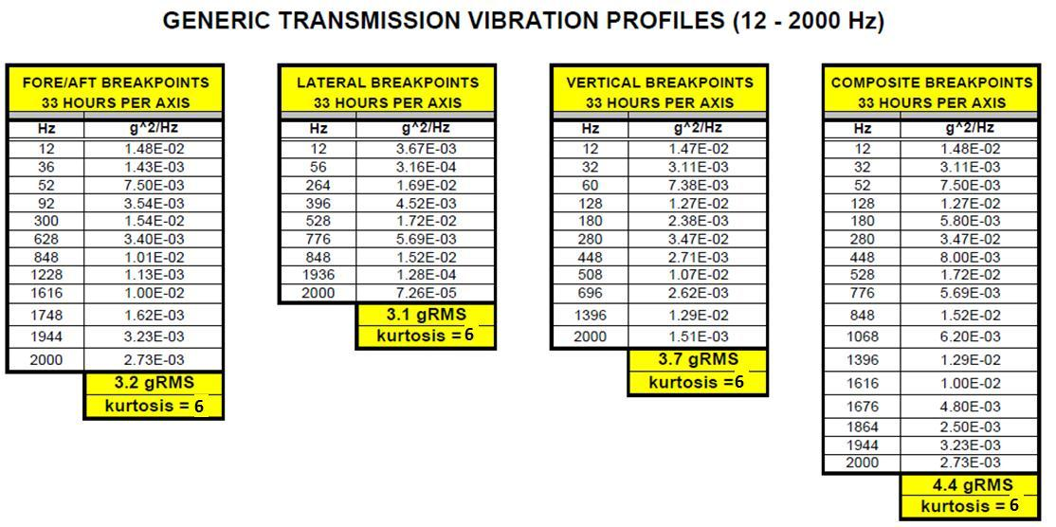

|  |  |
| --- | --- |
| **Number of Samples on Test** | **Vibration Profile Repetitions** |
| 18 | 2.6 |
| 21 | 2.5 |
| 24 | 2.4 |
| 27 | 2.3 |
| 30 | 2.2 |
| 33 | 2.2 |
| 36 | 2.1 |

|  |  |
| --- | --- |
| **Test Point** | **Pass / Fail Criteria** |
| During Test | Continuously monitor all connector circuits for anomalies. |
| End of Test | The devices under test shall satisfy the function, performance, and visual evaluations as specified. |

### Component Cycle Test

This test is performed to verify that the device under test is not damaged by contaminated fluid cycled in the vehicle environment. The potential product failure modes and effects detected in this test are electromechanical component wear out and/or damage, material deformation, and loss of functionality.

Since the duty cycle of the VFS will be defined both by the command sequences associated with shift control and the action of the regulator and boost valves in the transmission system, the test must be performed in a fixture approved by General Motors that includes a clutch regulator valve, a boost valve, and a clutch load. Regulator valve control pressure must be monitored throughout this test to ensure the solenoids are truly cycling.

The number of samples on test (VFS level) as picked by the supplier should correlate to the number of cycles as indicated on each component of the VFS as shown in Table 4-5. There shall be two separate shift profiles to test, with each shift profile equal to one cycle. One cycle will be 1.5 seconds long, and there shall be a .2 second interval with Commanded Current equal to 0A between cycles. The density of the two cycles will be as follows:

3-10 hz Square wave cycle—70% of total test cycles

3-Normal Engagements –5% of total test cycles

WOT engagements – 25% of total test cycles.

The profiles for both cycles are shown in Table 4-3 and Figures 4.16.7.1 and 4.16.7.2.

Table 4-3

|  |  |  |
| --- | --- | --- |
| **Time (msec)** | **Commanded Current (A)** | |
| **WOT Engagements– 2100 kPa supply Pressure** | **Normal Engagements – 1500 kPa Supply Pressure** |
| 0 | 0.200 | 0.200 |
| 100 | 0.700 | 0.450 |
| 200 | 0.300 | 0.300 |
| 300 | 0.450 | 0.400 |
| 500-700 | Ramp to 0.600 | Ramp to 0.500 |
| 700 | 1.00 | 0.425 |
| 1000 | 0.500 | 0.375 |
| 1200 | 0.400 | 0.325 |
| 1350 | 0.200 | 0.200 |
| 1500 | 0.0 | 0.0 |



Figure 4.16.7.1 Figure 4.16.7.2

The contaminant shall be a mixture of the contaminants “Synform IV” from Fluid Technologies, Inc, Grade S-1641 Micropowder Iron from International Specialty Products, ECCC carbon fiber and the fluid shall be DEX VI oil at contamination levels as in Table 4‑4.

Table 4‑4. Contamination Testing Cycles and Mixture Level

|  |  |  |  |
| --- | --- | --- | --- |
| **PERCENT OF LIFETIME (%)** | **CONTAMINATION LEVEL (mg/L)** | **CONTAMINATION TYPES** | **CONTAMINATION TOP-OFF**  **RATIO BY WEIGHT SYNFORM / MICROPOWDER / CARBON FIBER** |
| 0 | 90 | Synform / Micropowder / Carbon Fiber | 4:1:1 |
| .36 | 40 | Synform / Micropowder / Carbon Fiber | 4:1:1 |
| 1.36 | 30 | Synform / Micropowder / Carbon Fiber | 4:1:1 |
| 2.73 | 25 | Synform / Micropowder | 4:1 |
| 3.64 | 20 | Synform / Micropowder | 4:1 |
| 60 | 45 | Synform / Micropowder | 4:1 |
| 90 | 70 | Synform / Micropowder | 4:1 |

The temperature profile is shown below in Table 4-5. The cooling/heating time between temperature settings shall be < 75 minutes. The temperature profile shall be repeated throughout the test.

|  |  |  |  |  |  |  |  |  |  |  |  |
| --- | --- | --- | --- | --- | --- | --- | --- | --- | --- | --- | --- |
| **Temperature °C** | 27 | 70 | 77 | 93 | 104 | 135 | 104 | 93 | 77 | 70 | Total |
| **Duration (hours)** | 2 | 6 | 12 | 4 | 2 | 9 | 2 | 4 | 13 | 6 | 60 |

A GMPT approved contamination test system must be utilized for all testing. The oil supply must have internal agitation to insure the uniform contaminant mixing throughout the test period. The levels of contamination must be maintained within 5 mg per liter of the specified contamination levels identified in Table 4‑4 and for the given test cycles. The contamination level is to be maintained by adding the appropriate ratios of the contaminants “Synform IV” from Fluid Technologies, Inc, Grade S-1641 Micropowder Iron from International Specialty Products, and ECCC carbon fiber from GMPT at the ratios specified for a given test cycle. The test fluid shall be one of the previously described mixtures at 70º ± 2º C unless otherwise specified. The oil supply shall have internal agitation to insure the uniform contaminant mixing throughout the test period.

Record the supply pressure and the control pressure for the duration of the test.

Audit tests will be performed after every 1 million accumulated cycles or change in contamination level. The oil to be used for these tests will be the contaminated oil that the solenoid was being tested with during the contamination test just prior to the audit. The data from the audit tests will be recorded and provided to GMPT at its request. The audit tests shall be performed only for the 70º C temperature. All solenoids shall pass the audit tests based off of the specifications for the specific test at 70º C temperature. After the audit tests are completed, the solenoid shall continue with its normal contamination cycle testing until the next audit tests are performed.

If any pressure control solenoid fails any of the above tests, then the contamination cycle testing shall be halted until the reason for the failure is fully investigated and reviewed with GMPT. The contamination cycle testing will then be allowed to continue upon approval by the supplier and GMPT.

Run all final validation performance tests in a “contaminated” transmission fluid which contains “Synform IV” from Fluid Technologies, Inc, Grade S-1641 Micropowder Iron from International Specialty Products, ECCC carbon fiber and GMNA factory fill automatic transmission fluid DEX VI oil and the ratio of contaminate mixture shall be 4:1:1. Use 20 mg/l of the mixture.

The final validation performance tests include all the pressure control solenoid tests as outlined in sections 3 of this document.

There shall be no functional, mechanical, or physical damage to the components or electrical connections after this test.

Table 4-5. VFS Sampling Plan



|  |  |
| --- | --- |
| **Test Point** | **Pass / Fail Criteria** |
| During Test | Continuously monitor all connector circuits for anomalies and Min/Max control pressure for each cycle. |
| End of Test | The devices under test shall satisfy the function, performance, and visual evaluations as specified. |

### Contamination Abuse Tests with Carbonyl Iron

This test is performed to verify that the device under test is not damaged by contaminated fluid cycled in the vehicle environment. The potential product failure modes and effects detected in this test are electromechanical component wear out and/or damage, material deformation, and loss of functionality.

A qualified contamination test system shall be utilized for all contamination testing. The oil supply shall have internal agitation to insure the uniform contaminant mixing throughout the test period.

Thoroughly mix the 1000-mg of CIP-S-1641 (Type E) Carbonyl Iron per liter of test fluid and run the test per the sampling plan. Measure the supply pressure, control pressure and command throughout this test.

Continuously monitor these parameters throughout the test to insure the solenoids are functioning as commanded. The test shall be performed at 90 ± 5º C. Use the following input signals for cycling:

Supply Pressure of 2100 ± 10 kPa and cycle at a 0.16 Hz square wave input from 0 mA to 1.1 Amp.

**Table 4-6 Contamination abuse test sampling plan**

|  |  |
| --- | --- |
| **Number of VFS’s on Test** | **CAT Test Cycles** |
| 6 | 5.20E+04 |
| 7 | 4.81E+04 |
| 8 | 4.50E+04 |
| 9 | 4.25E+04 |
| 10 | 4.03E+04 |
| 11 | 3.84E+04 |
| 12 | 3.68E+04 |
| 13 | 3.53E+04 |
| 14 | 3.40E+04 |
| 15 | 3.29E+04 |
| 16 | 3.18E+04 |
| 17 | 3.09E+04 |
| 18 | 3.00E+04 |
| 19 | 2.92E+04 |
| 20 | 2.85E+04 |
| 21 | 2.78E+04 |
| 22 | 2.72E+04 |
| 23 | 2.66E+04 |
| 24 | 2.60E+04 |
| 25 | 2.55E+04 |

Pressure Control Solenoids: Verify that the control pressure continuously maintains a consistent rise and decline for each cycle and that they reach the minimum and maximum control pressures defined in Section 3. Check specific solenoid control pressures at 0, 10,000, 20,000, and 30,000 cycles. The solenoids shall not fail to operate during this test and shall pass all functional requirements (Section 3 Requirements).

|  |  |
| --- | --- |
| **Test Point** | **Pass / Fail Criteria** |
| During Test | Continuously monitor all circuits for anomalies. |
| End of Test | The devices under test shall satisfy the function, performance, and visual evaluations as specified. |

### Mechanical Shock Test

A baseline shock of 25g to 100g peak, half sine wave, and 15-millisecond duration shall be applied in the direction parallel to the normal vertical-mounting axis.

#### Procedure

**STEP 1:** Mount sensor assemblies on mechanical shock test machine in the specified orientation.

**STEP 2:** Subject sensor assemblies to 25-g peak/15-msec half-sine shocks along +X axis.

**STEP 3:** Subject sensor assemblies to 25-g peak/15-msec half-sine shocks along -X axis.

**STEP 4:** Subject sensor assemblies to 25-g peak/15-msec half-sine shocks along +Y axis.

**STEP 5:** Subject sensor assemblies to 25-g peak/15-msec half-sine shocks along -Y axis.

**STEP 6:** Subject sensor assemblies to 25-g peak/15-msec half-sine shocks along +Z axis.

**STEP 7:** Subject sensor assemblies to 25-g peak/15-msec half-sine shocks along -Z axis.

**STEP 8:** Subject sensor assemblies to 100-g peak/15-msec half-sine shocks along +X axis.

**STEP 9:** Subject sensor assemblies to 100-g peak/15-msec half-sine shocks along -X axis.

**STEP 10:** Subject sensor assemblies to 100-g peak/15-msec half-sine shocks along +Y axis.

**STEP 11:** Subject sensor assemblies to 100-g peak/15-msec half-sine shocks along -Y axis.

**STEP 12:** Subject sensor assemblies to 100-g peak/15-msec half-sine shocks along +Z axis.

**STEP 13:** Subject sensor assemblies to 100-g peak/15-msec half-sine shocks along -Z axis

#### Test Conditions Table

|  |  |  |
| --- | --- | --- |
| **Test Condition** | **Units** | **Parameters** |
| Total Mechanical Shocks per DUT |  | Per sampling plan |
| Operational Mode |  | Non-Operating |
| Temperature | °C | TAMB |
| Wave-form |  | Half-sine |
| Peak Acceleration | g | Per Procedure |
| Shock Duration | ms | 15 |

**table 4-7 Mechanical shock test sampling plan**

|  |  |
| --- | --- |
| **Number of solenoid’s on Test** | **Mechanical Shocks in Each Direction** |
| 12 | 1323 |
| 13 | 1257 |
| 14 | 1202 |
| 15 | 1156 |
| 16 | 1116 |
| 17 | 1081 |
| 18 | 1050 |
| 19 | 1023 |
| 20 | 998 |

|  |  |
| --- | --- |
| **Test Point** | **Pass / Fail Criteria** |
| During Test | Continuously monitor all circuits for anomalies including intermittent open circuits. |
| End of Test | The devices under test shall satisfy the function, three temperature performance, and visual evaluations as specified. |

### High Pressure Test

Subject the 6 VFS’s to an elevated supply pressure of 3102.6 kPa at a fluid temperature of 90º ± 5ºC for 5 minutes (minimum). There shall be no functional, mechanical, or physical damage to the VFS.

### Shelf Storage Test

Corrosion Test

Solenoids are to be stored in the production shipping carton in an environment of 70-100% relative humidity at 23 °C for a minimum of 30 days. Packaging to be DV tested only. Any change to packaging or VFS corrosion protection requires GM Design and Release Engineering to determine if a new DV test is required.

**Requirements:** No visible corrosion is to be found internal or externally. The solenoids must conform to requirements in Sections III of this document upon completion of this test.

### ~~Drop Test~~ REMOVE. BW proposes that a dropped solenoid is rendered as scrap. Requirement was removed from GF6.

Drop a minimum of 6 VFS’s from a height of 1.2 m onto all six faces. If the VFS is not physically damaged in such a way as to prevent proper installation into the transmission, it shall still function properly. If the VFS does not survive or function properly, the VFS performance shall be detectable in such a way that prevent drop must have physically damaged the VFS in such a way to prevent proper assembly into the transmission.

### Connector Validation per GMW 3191

The VFS supplier shall verify that the connector supplier has validated the connection system to GMW3191 (*Connector Test and Validation Specification*) and the test plan shall be executed on the actual component assemblies. This will require the component supplier to provide samples (free of charge) for validation testing at the connector supplier at each design level (DV/PV).

**Note:** The above test names are according to GMW3191, revision December 2007. The tests shall be performed according to the latest version of GMW3191.

### Contamination Dwell Test

#### Test Contamination Levels

Use the same contaminate concentrations specified in the GM Component Technical Specification for VFS component life cycle testing. (90mg/l) of Synform, Micro Powder, and Carbon Fiber with at ratio of 4:1:1 respectively. In addition to the above, add 45 mg/l of hardened Fe particles 0 to 60 µm.

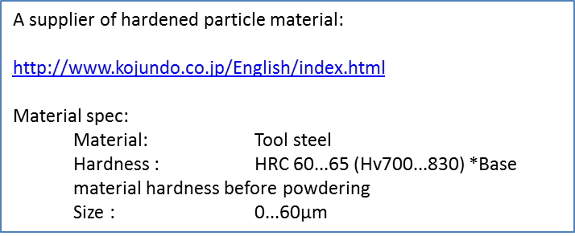

#### Test Conditions

Target particle count concentration 25/23/19 using ISO 4406:1991 (2 μm(c), 5 μm(c) and 15 μm(c))

Temperature = 45 °C

Current Command Profile:

10 minute current sufficient to achieve mid pressure (550 mA for the 6T70)

50 cycle of P/I curve sweep using minimum step size with 20 second period.

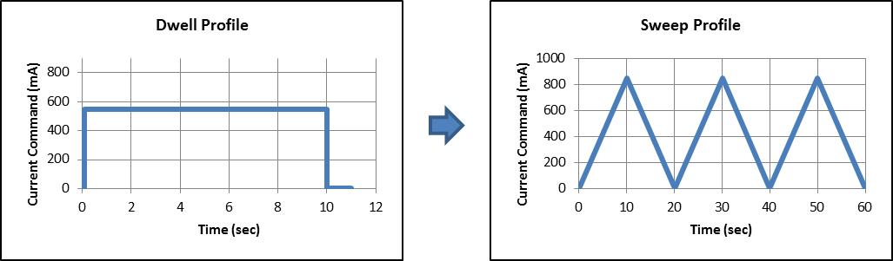

#### Performance Measurements during Dwell Phase

Plot VFS output pressure, supply pressure and oil consumption rate over the 10 minutes of constant pressure command. Decreases in flow rate and/or VFS output pressure indicate particles are collecting around the valve.

Target: Less than +/- 50 kPa change in VFS output pressure.

#### Performance Measurements during Sweep Phase

Record the minimum and maximum pressure achieved on the first sweep. Count the number sweeps required for the P/I curve shape to meet the following conditions:

* Max and Min pressures are reached, on steps in the P/I curve shape,
* Hysteresis within spec limit

Target: 1st P/I curve to achieve normal min and max pressure, without steps in the curve shape and hysteresis within specification.

#### Stretch Goal of Test

VFS must function well on the first P/I curve sweep after a 10 minute dwell. Stretch goal is to pass the first sweep after a 30 minute or greater dwell. The same sweep performance is required when Full-On and Full-Off states are commanded.

# Appendix

## Hydraulic Load Assembly

**Okeefe Orifice # D-7-SS, .0071inch orifice diameter, 303 Stainless Steel. Exhaust VFS control pressure to atmosphere.**

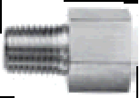

**\*Note:**

The following flow requirements for the hydraulic loads shall be verified for each solenoid position. It is the suppliers’ responsibility to determine the PM schedule necessary to ensure that the hydraulic loads meet this requirement throughout the development of this program.

Verify the hydraulic load to flow 50 ±5 ml/min with 758 ±10 kPa supply pressure at 70º ±2C.

Test Stand Accumulator

* Piston diameter = 12.78 mm
* Piston stroke = 8 mm
* Spring rate = 27.1 N/mm
* Spring preload = < 1.0 N
* Volume vs pressure = 0.607 mm^3 / kPa
* Total accumulator volume = 1026.22 mm^3 (1.026 mL)

## Important to Function / KPC / DR requirements

Use GM Powertrain KCDS (Key Characteristic Designation System) manual as a reference.

Items/features that are considered “Important to Functions”, but are not limited to the following:

* Features that affect the assembly of the pressure control solenoid into the valve body.
* Sealing features of the pressure control solenoid
* Hydraulic functions and features of the pressure control solenoid and on/off solenoid that may affect the hydraulic functionality.
* Valve Body sealing surface features.

Refer to the GMPT Process Capability procedure (GM1927-3) for additional information

## Establish & Implement Plan for Pull-ahead Production Tooling

This section defines the requirements for supplier tooling for use in Pre-Production builds.

Pre-production parts for use in build phases prior to Gamma can be made using prototype soft tooling upon GM approval. These parts can be designated as non-critical parts on the PPQP documents.

GM shall establish any pre-production part as a *Critical Part*, if the parts have been manufactured using pull-ahead production tooling but have not yet received full PPAP approval. Refer to the Pre-Production Part Quality (PPQP) documents for critical part submission guidelines. *Critical Parts* shall be released under the authorization of a GM Tooling Release Work Order if pull-ahead production tooling is required.

Supplier shall submit a pre-production tooling quote (1810 Tooling Detail Form) prior to source selection.